Most of these changes listed should have already been implemented as per the up to date changes sent 05/03/14.

1. Tabs:

Actual

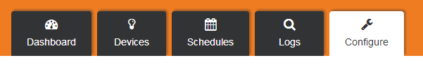

Designed

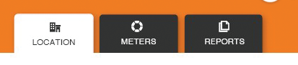

* 1. Note the designed tabs are all a set width. They are elongated and slightly more narrow. The drop shadow is soft and subtle.
  2. The text is all in capitals and appears slightly smaller sized. The icons are crisp, clean and detailed.
  3. The alignment of the tabs should not be far left… they should be to the left but currently the tabs are so far to the left it unbalances the whole look.

1. Logo

Actual



Designed



* 1. We are OK with the actual colourway. But the issue is the designed has a very faint centered dropshadow. This adds more lift to the design.

1. Layout

Actual

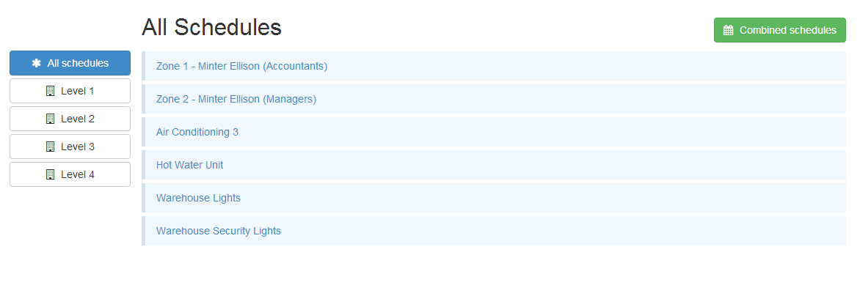

Designed

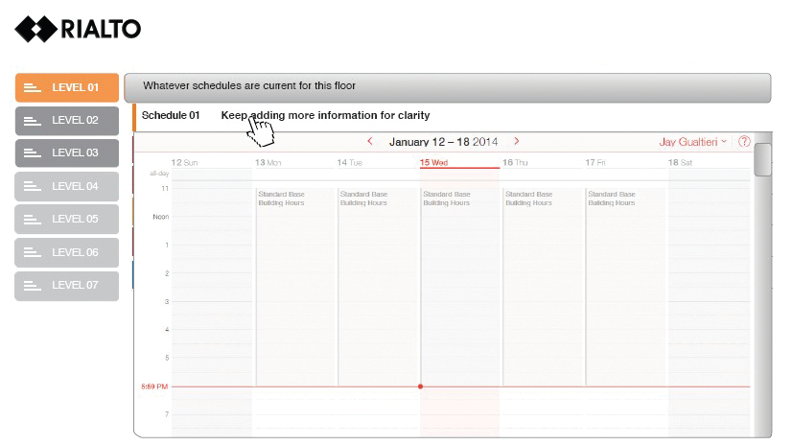

* 1. The client logo is not prominent on the graphic, the level buttons are not the same as the designed full faded version.
  2. The schedules rows are not the same as the example. More of a button effect.
  3. There are no colour indicators as per the designed example. There are no icons per row for shortcuts as per the v1.1 design notes.

1. Use sitesync icon logo for favicon from sitesync facebook page <https://www.facebook.com/SiteSync/photos/a.178454735685397.1073741825.118355395028665/178455822351955/?type=1&theater> NOTE MFDC HAS AN ILLUSTRATOR VERSION OF THIS FILE FOR TRANS[ARENT BACKGROUND. instead of this



1. This sign in page needs to be inline with what was designed with Sandra…

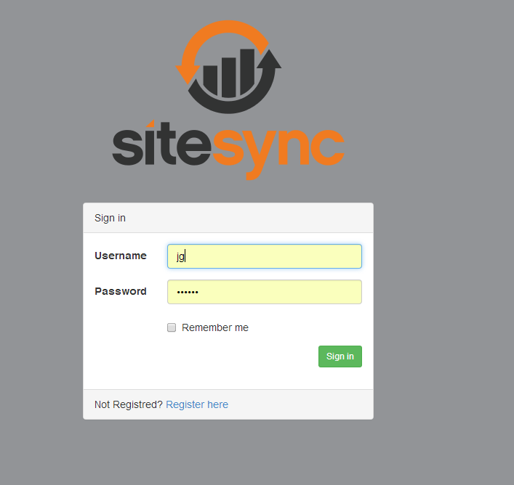

1. The dashboard background needs more depth…. An overlayed detail of a commercial building zoomed in like in this vein would be an option… please feel free to use your creative genius as this is the first visual thing users see when they log on!!!! Very important

